[Your Name]
[Instructor]
[Class]
[Date]

why teachers should be paid more

Introduction
Every one of us recalls fond memories of childhood every once in a while. And in our memories, some of our favorite and unforgettable teachers often get into the scene to paint a smile on our face. They have taught us the basics of surviving the ever-demanding society. And even if things weren’t perfect between us and our teachers, we can never deny the fact that a part of who we are had been strongly influenced by our teachers. As Henry Adams once said, “A teacher affects eternity; he can never tell where his influence stops.”
Yet, they don’t seem to get the respect they deserve from this nation. Why do I say that? Just take a look at their average salary. It is true that most teachers get into the profession of teaching for reasons nobler than monetary benefits. But that doesn’t mean they should not be compensated well. Let me give you three reasons why teachers definitely deserve a raise.
Body
- It will save the USA billions of dollars.
First, let’s look at the most practical side of the issue. The New Teacher Project (TNTP) estimates that over 10,000 of the nation’s highest performing teachers leave the classroom every year and among the reasons is low compensation. In fact, one million American teachers are projected to leave their profession in the next several years. Once these teachers leave, we also lose the chance of developing experience among these professionals. Furthermore, the cost of attrition would range from five billion dollars to over seven billion per year. The government will have to spend so much on training new and inexperienced teachers.
Instead of having to spend much for repairing damages, why don’t we just increase their pay so they stay in the field and we enjoy better services from more experienced professionals?
- Increasing teachers’ salary will encourage the brightest students to pursue a career in education, attracting the talent we need for this important job.
Since teachers have such a significant impact to society and to our nation’s future, it is only imperative that we have the best and brightest talents in the field. When our teachers are skilled and smart, the products of our educational system will also be skilled and smart. With the current rate of teachers’ pay, however, the brightest students often do not see teaching as a desirable career.
Although teaching can be a very rewarding job, its low financial incentives make it look less respectable, compared to higher earning careers such as medicine and law. American teachers today make only 67 to 72 percent of what bachelor holders usually earn. So, even if some brilliant students with so much to share would want to take up teaching as a lifetime career, they might be discouraged to live their dream because they would also like to secure some financial freedom in their lives.
- Teachers spend their own money for work-related expenses.
Aside from being paid lower than other bachelor holders, teachers’ income become even smaller once the cost for their work-related projects and expenses are deducted from their net pay. First, most of them will have to pay for their own graduate studies and ongoing professional trainings. Second, 92% of them buy supplies for their classroom and students with their own money. To make ends meet, 60% of teachers have been reported to engage in second jobs.

Conclusion
We need to pay teachers more because the future of America depends on how we see education today. Continuing to offer salaries that discourage rather than encourage our brightest students from entering and staying in the profession will put future of this nation in jeopardy.

Works Cited
Strauss, V. (2014 March 25). Why teachers’ salaries should be doubled — now. Retrieved from http://www.washingtonpost.com/blogs/answer-sheet/wp/2014/03/25/why-teachers-salaries-should-be-doubled-now/
Alfuth, J. (2013 April 30). Hey Dad, Here's Why We Should Pay Teachers More. Retrieved from http://www.huffingtonpost.com/teach-plus/hey-dad-heres-why-we-shou_b_3184945.html
Polloi, H. (2013 July 13). The Top 11 Reasons Teachers are Undervalued. Retrieved from http://www.dailykos.com/story/2013/07/13/1223340/-The-Top-11-Reasons-Teachers-are-Undervalued#

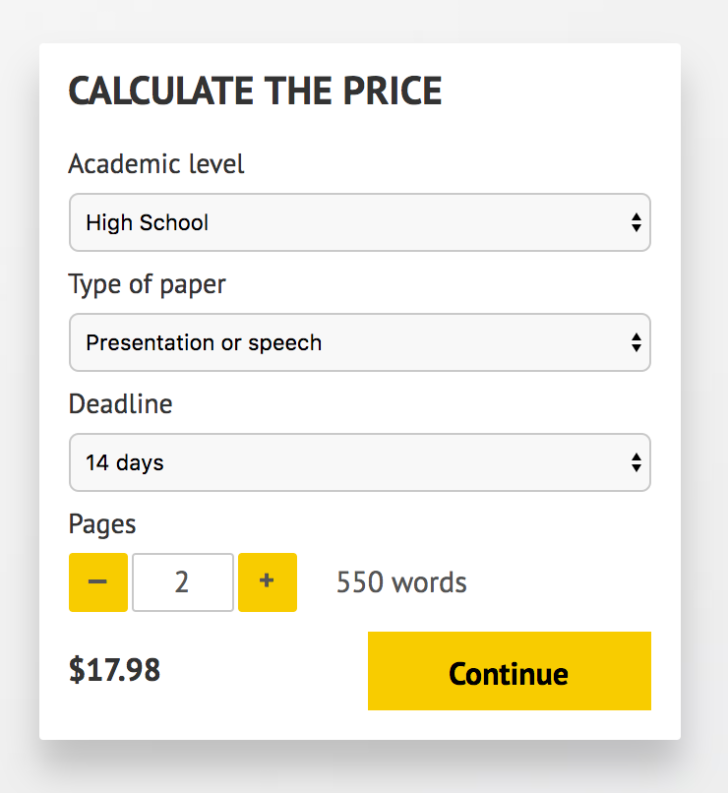
IMPORTANT – PLEASE READ
Don't use this speech as is! This document is available for anyone to download, and it has been used by thousands of people.
If you need help with writing a unique speech, please go to http://www.myspeechclass.com/go/custom-speech - you can order unique speech for as low as $17.98.

