[Your Name]
[Instructor]
[Class]
[Date]

DRUG TESTING FOR STATE AID

Introduction
- Technically, State Schools Receive State Aid
How many people in here have a state-funded scholarship -- you get money from the government to help you pay for school? How would you feel if, before you could get your scholarship, you had to go down to Student Health, pee into a cup (and you know, maybe get some blood drawn) and have them run a drug test on you before you could get access to your scholarship? You'd all probably do it, because we as college students need as much free money as we can get. Before, during, and after, you'd probably complain to your friends about how stupid and wasteful it was, but you'd do it. Now let's step it up a notch: what if, before professors could cash their paychecks, they had to go down to Student Health and pee into a cup for a drug test? Here's the thing: today, before people receive state aid and welfare in our country, they have to go through that kind of a drug test. This isn't a country-wide thing, but it does happen here, and legislators are working to spread it further. Today, I'm going to talk about why people who receive state aid should not be drug tested

body
- Misinformation Leads to Prejudice
To be honest, drug testing people who receive state aid sounds like a great idea: poor people are poor because they're all hippies who waste their money on booze and drugs, right? As middle-to-upper class Americans, we don't want the money we pay our government to go to people who waste their money like that. Logically, requiring people to get a drug test before they can receive state aid should weed out those people. However, that logic only works when all the proposed statements are true. Generalizing all people on welfare as drunk, stoned hippies is not only racist, but untrue: the bottom 30% works longer, harder hours than anyone else, because they work nights and weekends.
- Drug Testing Does Not Save Money
People argue that testing for state aid helps save money, because we aren't giving welfare to drug addicts etc. Florida is a great case study for this -- in 2011 it passed this kind of a law into effect. The law didn't last long, because it was ruled unconstitutional (which is a matter for a discussion at a different time), but the numbers were humbling. Not only did less than 3% of the tested participants test positive for illegal drugs, but the state lost about $50,000 implementing the tests in addition to the costs of distributing welfare. The law also didn't inspire people who used state aid from trying to float it on their own. The number of cases was average. People jumped through the hoops not because they want to screw the system, but because they needed help.

CONCLUSION
- An Imperfect Solution
Am I saying that there aren't any stone-drunk hippies that use welfare? Absolutely not. I'm saying that we shouldn't be taking measures to further humiliate and complicate the lives of those on welfare; we should be making legislature that actually helps people who need state aid to get to a place where they don't need it anymore. Keeping EBT users from being able to purchase alcohol and/or cigarettes might be a place to start. I don't know, because the truth is that nobody's asking what would help the poor. We're all just asking what will help us, what will make our money the most effective. That's a noble goal, but when it comes at the cost of human lives, it become ignoble. In the end, drug testing for state aid is a waste of money, money that could be spent in bettering human lives.
Thank you for your attention.

WORKS CITED
Bloom, Rachel. "Just as We Suspected: Florida Saved Nothing By Testing Welfare Applicants." American Civil Liberties Union. 18 Apr, 2012. Web. 15 Nov, 2014.
"Drug Testing For Welfare Recipients and Public Assistance." National Conference of State Legislatures. 6 Nov, 2014. Web. 15 Nov, 2014.
O'Brien, Matt. "Why do so many Americans work nights and weekends? Blame inequality." The Washington Post. 7 Oct, 2014. Web. 15 Nov, 2014.
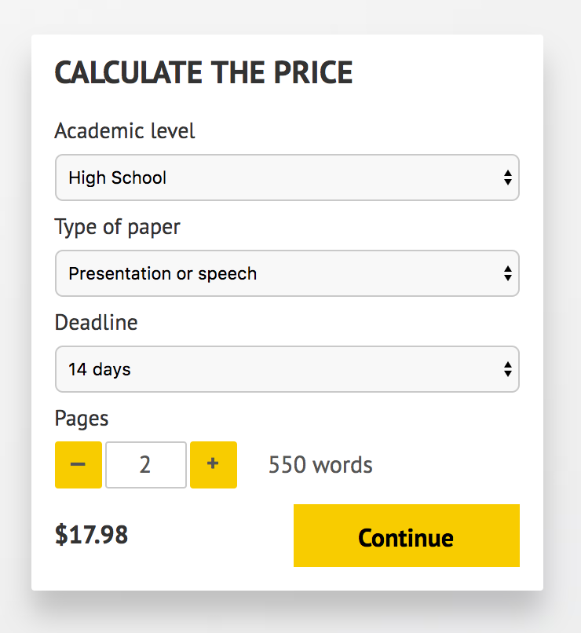

IMPORTANT – PLEASE READ

Don't use this speech as is! This document is available for anyone to download, and it has been used by thousands of people.

If you need help with writing a unique speech, please go to http://www.myspeechclass.com/go/custom-speech - you can order unique speech for as low as $17.98.

