[Your Name]
[Instructor]
[Class]
[Date]

Robin Williams

Introduction
- Attention Getter: A comedian, an actor, an inspiration, and a troubled man. This past August, the world lost one of its most beloved figures, Robin Williams.
- Topic Clarification: At the age of 63, he lived a life of profound impact on the world. From television to the big screen, he invoked both laughter and tears. His characters served as an expression of his passion, and also concealed the man behind them.
- Roadmap: Today, I will try to elucidate both. First, I will describe a few biographical facts on Robin’s life before and beside his professional career. Then, I will provide a brief overview of the roles and successes within this career. Finally, I will briefly mention the depression and troubles that plagued him.

body
- Main Point: Let’s begin with some information on his personal story.
- Robin Williams was born in Chicago on July 21, 1951 (Biography.com).
- The sibling of two elder half-brothers, he was more accurately an only child, and in an interview with NPR he said that he was very shy as a kid (Gross 2006).
- According to IMDB, he was also a very overweight child, and was often lonely. As a result, he entertained himself with vocal impressions (IMDB 2014).
- He also said that his mother was an early source of his sense of humor, as he tried to get her attention with it (Gross 2006).
- After finding his passion in drama in high school, Robin attended Julliard School in New York. He later moved to practice comedy in California, developing the stand-up act that launched his career (Biography.com 2014).
- Later, Robin married three times. The first was Valerie Velardi, with whom he was married from 1978 to 1988 and had one child, then Marsha Williams from 1989 to 2010, with whom he had two children. He married Susan Schneider in 2011, with whom he remained until his death (IMDB 2014).
- Main Point: An interesting and successful career flourished in the meantime.
- Williams had done some television work in the early 70’s before debuting as the alien character Mork on “Happy Days” in 1974. There was such a positive response that it birthed the subsequent spin-off “Mork and Mindy” in 1978 (IMDB 2014).
- Williams noted that a lot of his inspiration came from Jonathan Winters, a coworker on Mork and Mindy, whose free-form, ingenuous style Williams idolized (Nachman 2003).
- Williams took part in a range of film roles over the next years. Playing leading roles in 1982’s The World According to Garp, and 1984’s Moscow on the Hudson. His roles in 1987’s Good Morning Vietnam, playing radio DJ Adrian Cronauer, and in 1989’s Dead Poet Society, playing teacher John Keating, earned him academy award nominations for lead actor (Biography.com 2014).
- We remember him humorously as the genie’s voice in Aladdin, the Scottish nanny in Mrs. Doubtfire, as Theodore Roosevelt in Night at the Museum, as well as dramatically in his roles in Good Will Hunting and Man of the Year.
- Yet the amazing range of roles and films in which he played shadowed his fatal illness.
- In an apparent suicide, Williams’ death likely resulted from depression.
- He occasionally commented on his sadness in the years immediately prior to his death, noting that he would “get bummed” and that things would hit him hard sometimes. He even spoke of occasional suicidal thoughts (Vokes-Dudgeon 2014)
- His friends and family mourn a loss whose hints they even recognized before it happened (Vokes-Dudgeon 2014).

CONCLUSION
- Transitional Signal: Though in spite of his tragic circumstances, it’s impossible to confuse the joy and passion Robin found in comedy and acting.
- Summary: With the information I’ve offered on his life today, we can remember him happily.
- Memorable Close: Regardless, he lives on in his work, and in the laughter and emotion it causes.

WORKS CITED
Biography.com. (2014). Robin Williams. Retrieved from Bio.com.
Gross, Terry. (2006, August 3). Robin Williams: ‘The Night Listener.’ National Public Radio.
IMDB. (2014). Robin Williams. Retrieved from IMDb.com.
Nachman, Gerald. (2013). Seriously Funny: The Rebel Comedians of the 1950s and 1960s. Panetheon, N.Y.
Vokes-Dudgeon, Sophie. (2014, August 12). Robin Williams' Depression in His Own Words, How Alcohol Once Led to Thoughts of Suicide. Retrieved from usmagazine.com.
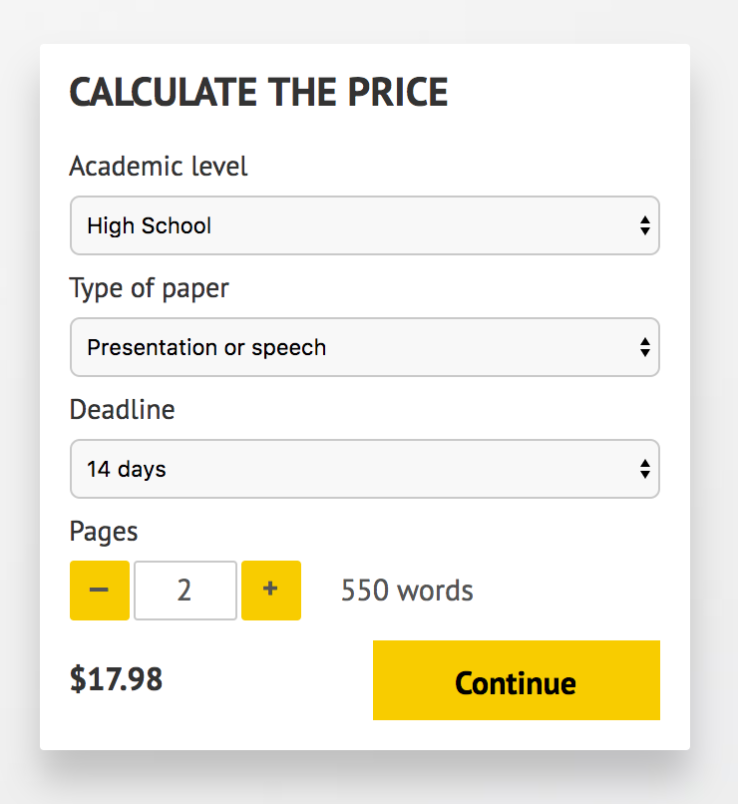
IMPORTANT – PLEASE READ
Don't use this speech as is! This document is available for anyone to download, and it has been used by thousands of people.
If you need help with writing a unique speech, please go to http://www.myspeechclass.com/go/custom-speech - you can order unique speech for as low as $17.98.

