[Your Name]
[Instructor]
[Class]
[Date]

why Drinking Alcohol will not Keep You Warm in Winter

INTRODUCTION

Halloween has just bid us farewell and another holiday is coming by. It sure is fun to have a white little Christmas this year. As the cold weather slowly sets in, we need to find ways in keeping our bodies warm, just so we can have real holiday fun instead of being stuck at home in layers and layers of pajamas. There are probably hundreds of ways so stay warm in winter without rendering us immobile. But among the more popular ones is having a tall mug of booze. But does alcohol really help keep our bodies warm.

BODY

- Alcohol Makes You Feel Warm A A
Obviously, alcohol does make us feel warm all over. After just a couple of nips, we always feel that gratifying flow of heat from our throats, creeping down to our esophagus, and finally to our awaiting tummies. Being a vasodilator, alcohol makes our peripheral blood vessels to dilate, pushing warm blood towards the surface of our skin, giving us an immediate relief from the cold, making us warm and even relaxed all at once. The heat flush we experience after a swig or two definitely make us feel warm because it is the skin that most of our “heat sensors” are located. The amount of blood supplied into the capillaries on the skin also increases in volume, making our skin glow pinkish and even sweaty under our coats.

- Alcohol Lowers Your Core Body Heat
However, this phenomenon is the exact opposite of how our body defenses work. Dr. William Haynes, Director of Clinical Pharmacology at the University of Iowa, said that consumption of alcohol undoes many of the human body’s healthy reflexes, one of which is keeping the core body temperature warm in cold weather. Normally, when it’s very cold, our blood vessels constrict, minimizing the amount of blood flowing through the capillaries in our skin. This way, our body preserves most of its heat inside and keeping our core body temperature up.
So, when our blood concentrates on supplying heat towards the surface, the process exposes most of our body heat to the cold atmosphere. The longer we expose ourselves to cold temperature, the more we lose our core body heat, the very thing we need to survive, especially when stuck in snowdrift. Eventually hypothermia sets it.
Another way alcohol makes us lose core body heat is by inhibiting our body’s ability to shiver, our body’s natural way of producing heat. A study made by the Army Research Institute of Environmental Medicine had proven this fatal phenomenon on people who sort to drinking in order to keep themselves warm.

- Alcohol Impairs Judgment
Alcohol doesn’t really help increase our body’s temperature. It just deceives us into thinking that it does. But aside from the physiological effects of alcohol, it also worsens the temperature problems by blurring our mind against making wise decisions.
According to Professor Malcolm Woollard, chair of the British Paramedic Association, the problems their paramedics deal with sometimes deal with people who have drank too much, who have missed the last bus home, passed out outside and ended up with hypothermia. “Then, of course, there are the people we treat that have been drinking and then slipped on ice or snow and hurt themselves. Alcohol and cold temperatures are a lethal combination,” he further explained.

CONCLUSION
Instead of ingesting bottles of alcohol, why not sip some hot tea or cocoa- drinks that will actually keep you warm from the inside, at the same time giving you lots of health benefits. Just cut down on the caffeine, though, as it also makes your body heat rise up to the skin, leaving your internal organs colder than you want them to be. Of course, the good, old layering up technique still works. But most of all, get that cold body moving to help your body burn all those stored energy and produce the natural heat you need for the winter.

SOURCES

(October 2014) Alcohol and cold weather. Retrieved at: https://www.drinkaware.co.uk/check-the-facts/effects-on-your-safety/drinking-alcohol-in-cold-weather

Hiskey, D. (October 2012) Alcohol Does Not Help Prevent Hypothermia, It Actually Makes It More Likely. Retrieved at: http://www.todayifoundout.com/index.php/2012/10/alcohol-does-not-help-prevent-hypothermia-it-actually-makes-it-more-likely/

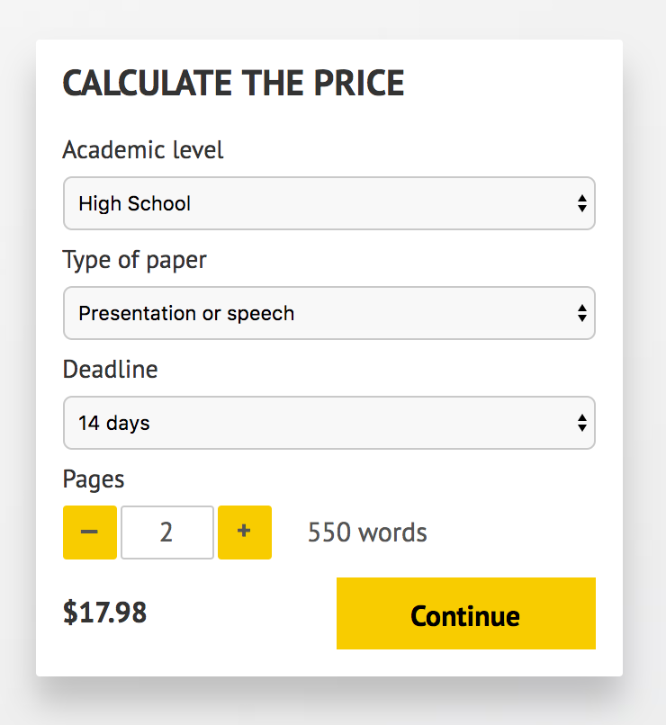

IMPORTANT – PLEASE READ

Don't use this speech as is! This document is available for anyone to download, and it has been used by thousands of people.

If you need help with writing a unique speech, please go to http://www.myspeechclass.com/go/custom-speech - you can order unique speech for as low as $17.98.

