it’s up to society to solve gun problems

Introduction
Have you ever been shot for knowing one who has? Chances are probably not. According to a research, California has the most anti-gun laws while Arizona has the least. Everybody has their own opinion on gun laws: what they should be, what dependent punishment should be, how it should be done?
However, the states with the most gun laws don't necessarily have the lowest crime rates. Mental illness is a bigger factor in a violent crime than the gun laws are. Finally, even though States border each other they don't have the same gun laws such as California and Arizona.

Body
I want everyone listen to this speech to realize that it is not the legislature to solve our gun problem it's up to society.
- Parents need to teach their children it is wrong to kill, to shoot, whatever. Don't rely on the schools to teach your children your principles or daycare that is a few.
Do you have young children go to school you worry about them being shot? That was not the concern 25 years ago and there were way less gun laws than there are today.
- Guns don't kill people, people kill people. If I could blame it on the guns I can blame my misspelled words on my pins or the car wreck on my car.
Idaho have one of the lowest gun laws and also one of the lowest crime rates. That could be for a number of reasons mostly psychologists blame it on mental illness more than the gun laws. Mental illness is the largest factor in dialect crimes. This includes mass murders and other gun related crimes.
States with higher mental illness have higher deaths related to guns. Suicide is included in the statistic so obviously that's going to add quite a few to the mental illness. The tragedy at Virginia Tech and the kinetic school both perpetrators were said to have had some sort of mental illness.
- Gun laws could not prevent these mishaps. Even if you take put in gun laws the criminals are still going to find guns. They're going to do whatever they're going to use a friend, family member, go to a different state which brings me to my final point is the states with different gun laws even though they border each other the gun laws can be so different criminals can just go to across the state line, get a gun, come back.
The top five anti-gun states are California, New Jersey, Massachusetts, Hawaii, and Connecticut. While on the other hand Idaho, Arizona, Vermont, Mississippi, and Kentucky for the most pro-gun states and as stated earlier Idaho has a very low crime rate.
If the laws were the same in each state then it would be a lot easier to control criminals going from state to state getting purchase guns.

Conclusion
I know you've listened to my speech and you all have your own opinion on what you think needs to be done. I hope after hearing my talk you have some new ideas.
I would like to think about and realize it is up to the citizens not the legislature. You have to be a parent you have to teach values, morals, right and wrong, not to kill, not to hurt. Remember you are the one raising your kids not someone else. It's up to you to do it an almighty dollar isn't the important thing your kids are - they're our future.
Thank you!

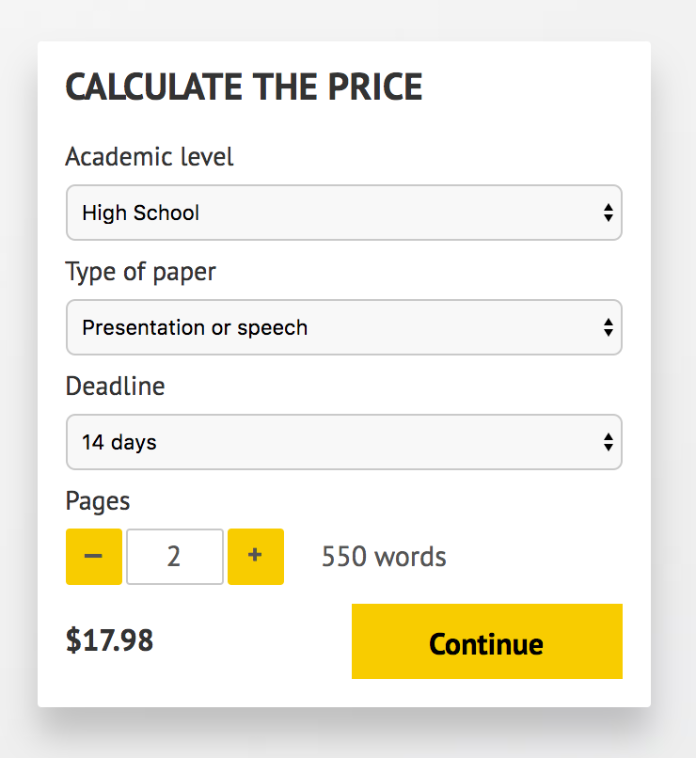

IMPORTANT – PLEASE READ

Don't use this speech as is! This document is available for anyone to download, and it has been used by thousands of people.

If you need help with writing a unique speech, please go to http://www.myspeechclass.com/go/custom-speech - you can order unique speech for as low as $17.98.

