Guns and gun control - texas

Introduction
Hi, my name is John Doe and today I will be talking to you all about guns and gun control and that pertains to the people here because we are in South Texas and Texas is known as pretty much the hillbilly state and a lot of people in Texas will mainly from Texas make up the majority of gun owners in America. So I feel like this does pertain to us based on the location where we are at.

Body
There are three main types of guns; you have your handgun, your rifle, and your shotgun. Rifles and shotguns are both classified as long guns mainly used for hunting and other sporting purposes. Handguns can also be used for sporting purposes and the firing types there is semi-automatic where you have one shot per trigger pool which automatically loads the round into the chamber for the next trigger pull and then you have fully automatic and that is where you hold down the trigger and it will fire off a number of rounds based on the duration of the trigger pull.
- People have different reasons for owning guns. Self-defense makes slash protection makes up 67% of the reasons why people have guns.
  - On target shooting or sport shooting is 66% of the reasons that people have guns.
  - Hunting is 58% of the reasons like it's 58% why people have guns.
- First I.O. and that also came from an article online and the next I will talk about a CNN article about the various presidents who signed various gun acts to limits a gun ownership and background checks and stuff like that.
  - First one we'll talk about is a Roosevelt. After the mini crimes committed by Al Capone back in the 30s the National Firearms Act was passed and that just put more regulations on guns, make guns harder to get, and so people like Al Capone or other mafia members could not illegally own guns that were not registered. That way in the database most law enforcement would know where guns are, who own guns, and who don’t.
  - President Johnson in 1968, this started after the assassinations of Robert Kennedy and JFK. This was a just mainly made it like Churchill licensing of guns like Lee Harvey Oswald he got his gun off the internet.
  - The next one we will talk about is President Reagan. In 1986 he signed the firearm owners Protection Act and what that did was banned future sale of fully automatic weapons or possession of fully automatic weapons from that time going forward. With that, gun owners free to pass their states without having to go through a checkpoint or a background check so if you are a legal gun owner you can travel from state to state with that gun.
  - The next one is President Bill Clinton in 1993 the Brady Bill named after James Brady that required federally licensed hand gun dealers to conduct background checks to all people that were going to buy handguns so if you were mentally incompetent or if you had a felony you are not allowed to purchase a handgun.
  - Another one by Bill Clinton was in 1994, it's an assault weapons ban and that was also signed by ex-presidents Ford and Carter and that banned the manufacturing, sale, and possessions of certain combat style weapons. It also pertained to students today because recently the Open Carry Act was passed and in years to come concealed handgun license owners will be able to have their concealed handgun license will be able to carry their weapon onto campus if the campus allows.

Conclusion
But of course, other people like myself, believe that if you are a licensed and trained individual, you should be able to carry your weapon where you please as long as it is yours and you know the designated area where you are allowed to have you ever.
But like Chris Kyle's wife Taya Kyle she believes that when her husband was killed she didn't blame the gun she blamed the person who was a drug user and have pushed my trust in him for the murder of Chris Kyle and his assistant because a lot of people will blame the guns for all that stuff but people like myself and Taya Kyle think that that was the person over the guns (the gun salesman) who was at fault because they allow the person who was mentally incompetent or those who was a drug user to have the gun and be AB access to that.
Thank you for your time!

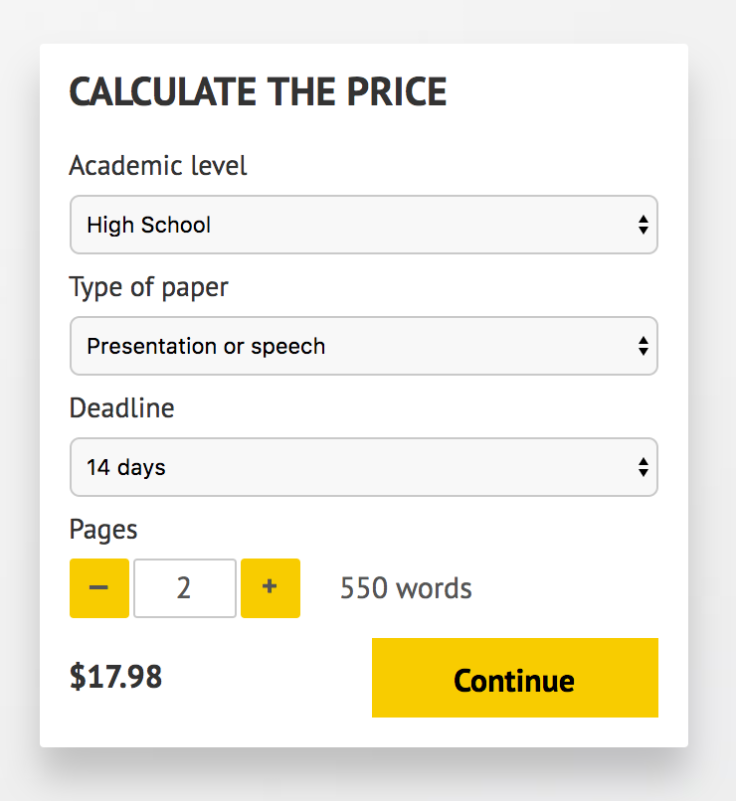
IMPORTANT – PLEASE READ

Don't use this speech as is! This document is available for anyone to download, and it has been used by thousands of people.

If you need help with writing a unique speech, please go to http://www.myspeechclass.com/go/custom-speech - you can order unique speech for as low as $17.98.

