Gun Control ON CAMPUSES

Introduction
Hi, my name is John and today's current event I want to talk to you about is gun controls on campuses.
The first thing I'm going to discuss is students and faculty Safety.
Second would be the half of the body of students and faculty who want to have concealed weapons allowed on campuses and the other half don't want it to have allowed.
Third would be the state of Texas allowing certain universities who allow concealed weapons in the campuses.

Body
- We are going to start off by students and faculty safety. I feel that our safeties are very important when we are going to get our education or to teach people their education as a faculty member. It is very concerning that nowadays we feel unsafe while to go to school knowing that hopefully someone right next to us in class or walking passes down the hall doesn't have a weapon on them.
The main thing is that I feel that the safety is so big because if you don't feel so comfortable it shouldn't be allowed on campuses. If the campus has a lot of problems that's what the University of Police is for to help us solve it and they're the only one should be able to have a gun on them.
For the faculty, they teach us (students) - learning their knowledge from them. But if they don't feel safe wanting to come and teach that's so important that they should feel safe; they should want to come and teach us (students).
- The second thing is that half of the students who do want to have the concealed license handgun to be allowed on campuses because they have one. They want to have that right to feel like “hey, I am safe and I don't care what everybody else thinks about it as long as I am safe”.
So half of the body of students would want one we want a lot of weapon to be allowed.
But would it be would it be safe for everybody or would it just be something to be selfish and that other half of the body would be not wanting it because that's not safe, we don't know what their attentions to be allowed that weapon, it is good or bad, why do you want to have it, why do you need it, and there's so many questions we want to ask but everybody's answers are going to be different.
- Three would be for this or leading to that is the state. State of Texas has allowed certain universities to have concealed weapons on their campuses. However, it did lead to certain regulations or rules to that. So some colleges who are allowed to have weapons, there are certain regulations they have to go by with a concealed weapon.
Concealed license means no one is supposed to know that you have weapon on you. That is the point of concealed that “no one knows”.

Conclusion
However, if you ever have been approached by an officer you have certain ways to tell him (the police officer) that you are a concealed license handle. We have signs all around campuses say concealed handgun are not allowed on campuses at all. However, when you are allowed to have them in your car but you are not allowed to have in the parking lot.
So, there are a lot of questions that in here what makes it allowed. That is what I have to say; wanting to know what everybody is depending on gun control; do you want it allowed or do you not want it allowed. What is your opinion?
Thank you!

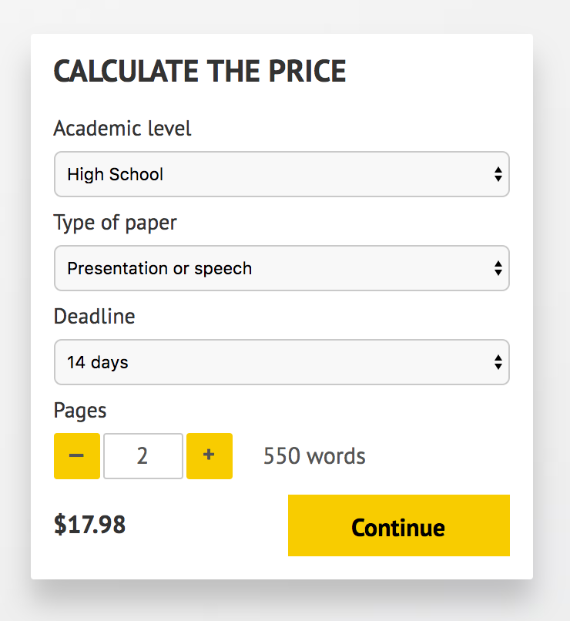

IMPORTANT – PLEASE READ

Don't use this speech as is! This document is available for anyone to download, and it has been used by thousands of people.

If you need help with writing a unique speech, please go to http://www.myspeechclass.com/go/custom-speech - you can order unique speech for as low as $17.98.

